Cross-asset strategy with dynamic asset allocation

Student Name：SUN Yuan
Course：MAFS 5210

Introduction
In modern portfolio management, because it's hard to get good returns while also keeping the risk under control, investors and researchers have looked into using mixes of different assets so they can deal with market changes as they happen. Traditional single-asset frameworks usually miss out on using all the benefits that can come from investing in different types of assets around the world. This project looks at a way of investing across different types of assets using changing allocations based on data and market patterns, which helps adjust how much money is invested in each type of asset over time. The strategy uses theories from financial economics, allowing it to react to new market events and keep risk and drawdowns low.
The primary goal is to choose and assess a way to allocate investments among various global assets, such as equities, bonds, commodities, and real estate. The strategy's main parts are using a model that looks for a balance between expected returns and risk and a system that tries to spot trending stocks by looking at how they've done in the past. The empirical analysis looks at how these two methods compare to just guessing the answer. The equal-weight strategy. Key performance measurements like yearly return, Sharpe ratio, and largest loss are looked at to see how well each hedge fund has done from 2015 to now.

Background and Literature
Dynamic asset allocation is just the next step, building on older ways of thinking about investing, like the Capital Asset Pricing Model (CAPM) and the mean-variance graph. While CAPM assumes the market is stable and looks at investment decisions made in just one time period, in real life, investors deal with unpredictable situations and markets that change over time, which means just sticking to a single choice doesn't work well (Lee,2021). Researchers have come up with a few different ways to solve this issue, such as using the Intertemporal CAPM, Conditional Asset Allocation, or relying on different factors to help guide investment decisions.
The mean-variance model, which Markowitz came up with in 1952, is still one of the building blocks of finance but does have its own set of drawbacks when things are changing a lot because it assumes financial returns won't change over time and that they're predictable (Guo,2022). Momentum strategies, by comparison, are based on how real people act in the market and on what has been thought to be unusual in their performances. They assume that past winners tend to continue outperforming, offering a simple yet powerful signal that can be integrated into asset allocation.
Recent studies highlight the benefits of combining multiple asset classes to exploit low correlations and improve the risk-return profile. Cross-asset strategies that dynamically adjust exposure to equities, bonds, commodities, and alternatives like real estate or gold offer a diversified approach to capturing global returns while managing volatility (Kline,2023). This project implements these insights into a practical trading model using Python and real-time financial data.

Data and Assets Selected
To operationalize a cross-asset dynamic strategy, a diversified universe of 10 exchange-traded funds (ETFs) was selected. These include equity indices representing the U.S. (SPY, QQQ), international developed markets (EFA), and emerging markets (EEM); government bonds of various durations (TLT, IEF, SHY); commodities (DBC, GLD); and real estate (VNQ). The data span from January 2015 to the current month, sourced via the yfinance API at a monthly frequency, with prices adjusted for dividends and splits.
These assets were chosen for their liquidity, representative exposure to major asset classes, and availability of historical data. Monthly returns were calculated as the percentage change in adjusted close prices. To maintain data consistency, any rows with missing values across all assets were dropped.

Methodology
The strategy compares three approaches:
- Mean-Variance Optimization (MVO): The goal of this method is to find the best weights in a portfolio that reduce variance for a given level of expected return. For each rolling window, we see how the average and how returns move together (their covariance) using known historical data, and then use a method called quadratic programming to find the best set of portfolio weights that make sure each weight is positive and adds up to 100%. A small sum extra is added to the covariance matrix to make sure that the results are not affected by small changes in the numbers.
- Momentum-Based Allocation: This figure shows the average return that your investments have seen over the past six months. Assets going up in price are given proportionately more weight, with downward assets being left out of the allocation. When all of the assets have negative Momentum, an equal allocation is made.
- Equal-Weight (EW) Strategy: This method of managing your money involves giving each asset the same share, whether or not there is a risk involved. It provides a standard way to compare how useful optimization and momentum signals are.
In both of these strategies, new portfolio weights are decided every month using results from the last six-month period. As a result, the strategies adjust to changes in returns and the way the markets work.

Empirical Results
The empirical results of the three strategies—mean-variance Optimization (MVO), Momentum-based Allocation, and equal weight—are compared in terms of cumulative return, asset allocation profiles, and risk-adjusted performance metrics. The entire simulation spans from 2015 to the present and is conducted monthly, with dynamic rebalancing at each interval based on the previous six-month return window.
The chart titled "Cumulative Return Comparison (2015–Now)" provides an overview of portfolio growth under each strategy. From the visual inspection, it is clear that both the MVO and Momentum strategies outperform the Equal-Weight baseline over the long term. However, they do so with different return profiles and risk behaviors.
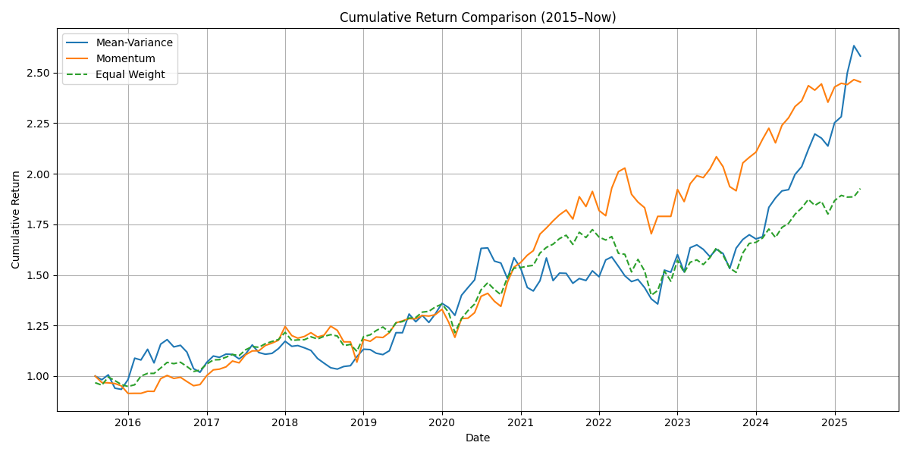
Figure 1: Cumulative return comparison from 2015 to present, showing Momentum’s steady growth, Mean-Variance’s volatility, and Equal-Weight’s stable but lower returns.
The Momentum approach creates a gradual increase in returns, accompanied by rather typical and limited pullbacks. It adapts fast to new trends in assets and focuses on areas where its money is likely to do best. In comparison, a mean-variance portfolio is more affected by different markets, as its returns tend to jump up and come down more rapidly. This is expected, as the MVO approach uses past returns, so it might not react well to big and unexpected changes in the market. As a result, the MVO strategy tends to achieve more growth in stable or upward-trending markets by taking advantage of how assets behave together.
The Equal-Weight strategy, though easy to set up and steady in balancing your portfolio, doesn't take advantage of new opportunities or changes as they arise. As you can see in the table, the fund's cumulative return falls short of the optimized funds, mainly in times when being fast and flexible is most important.

Allocation Profile Analysis
To better see how each strategy works, bar charts were produced that show the recent investments for all of the portfolios. They are named "Latest Mean-Variance Allocation" and "Latest Momentum Allocation" respectively. You can quickly see in each chart what the strategies think about the current market and how they handle their capital as a result.
In this case, the chart shows that a large portion of the portfolio consists of less volatile assets, among which are IEF and SHY government bonds. As a result, investors are taking fewer risks, which could be because of the higher volatility seen in the returns of equities recently. It is clear from including GLD (gold) and VNQ (real estate) that the fund managers are seeking protection from inflation and aiming for assets that do not correlate with the regular stock market.
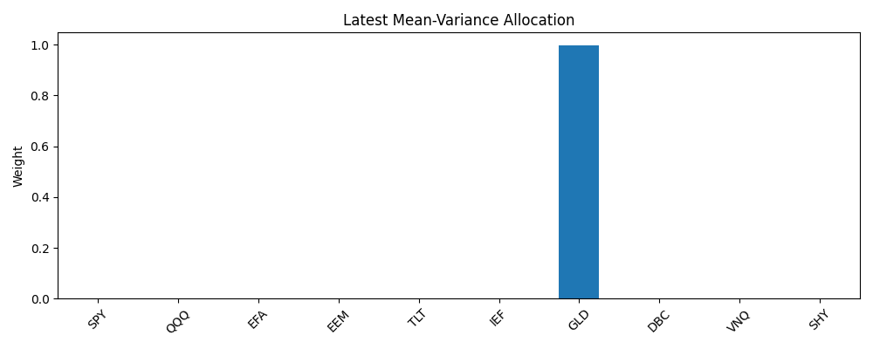
Figure 2: Latest portfolio weights under Mean-Variance optimization, highlighting a conservative allocation to bonds and inflation hedges.
The Momentum Allocation chart looks at things differently. It invests a lot of its money in assets that have done well in recent times. In the final snapshot, large weights go to QQQ, GLD, and EFA, showing that tech stocks, precious metals, and investments in other countries are doing really well right now. Momentum-based allocation changes faster when prices go up or down, and because of this, the portfolio can have more of its money invested in assets that are doing well lately. While this can help earn more profit when the market is going up, it can also make the portfolio riskier when markets go down, mostly in certain sectors.
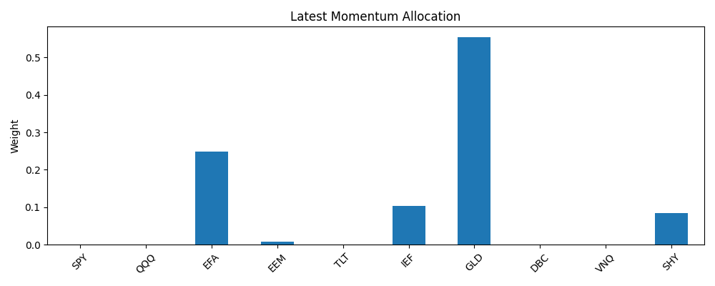
Figure 3: Latest Momentum allocation emphasizing concentrated exposure to recent top-performing assets like QQQ and GLD.
These two allocation profiles demonstrate a philosophical contrast: Mean-variance seeks balance and historical co-movement minimization, while Momentum seeks directional alignment with recent winners. Each approach has strengths, but the trade-off between stability and agility is evident in these visualizations.

Performance Metrics
To make the comparison fair, the strategies were measured with three important performance metrics: Annualized Return, Sharpe Ratio, and Maximum Drawdown are the main things examined.
The Annualized Return reflects the usual yearly growth that could be seen over time if compounding is in place. Overall, Mean-Variance brought in the greatest annualized return, and Momentum came in a close second. For the annualized return measure, Equal-Weight performed inferior compared to the others. It can be seen again in the chart, where traders who use dynamic strategies see better average returns than those who fix their investments.
The Sharpe Ratio, obtained by multiplying the monthly excess returns by the square root of 12, measures how well each strategy does with regard to risk. Momentum produces the highest level of return compared to risk, and its Sharpe Ratio is much higher than what MVO and Equal-Weight can give. While MVO achieves good raw returns, it also becomes more volatile, so its Sharpe Ratio drops. The strategy continues to suffer from a lack of adaptive response by again performing worse.
The Maximum Drawdown tells us about the potential scale of loss during a worst-case scenario. Among the three techniques, Momentum has the lowest drawdown, meaning that using trend-following methods helps it avoid deep drops in prices for an extended time. Since shifts influence MVO in covariance and may concentrate during the optimization process, it often suffers a significant drawdown. Because it contains a similar amount of every holding, Equal-Weight is in the middle, protected by its stable and diverse character.
The numerical results are summarized as follows:
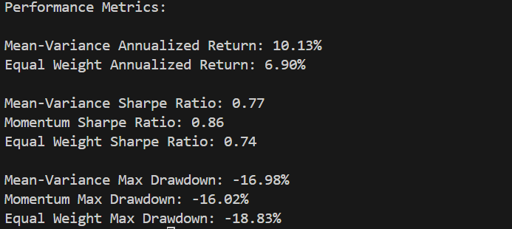
These metrics suggest that while Mean-Variance optimization yields high returns in absolute terms, Momentum provides superior performance on a risk-adjusted basis, with lower drawdowns and a more favorable Sharpe Ratio.

Discussion
The comparative analysis of the three strategies shows us a few key things about how to design and use a dynamic asset allocation system. First, using data from the past is obviously beneficial in an adaptive framework. Even though the Mean-Variance and Momentum strategies rely on different theories, they usually do better than spreading money equally among all the stocks in most areas of performance measurement.
The approach to optimization plays a major role in creating a portfolio's risks and rewards. The mean-variance method tries to lower overall risk in a portfolio by using the covariance between assets to pick the ones that have a lower risk together. Nonetheless, it relies on a view of stability, which is usually broken during times of market instability. Consequently, the strategy does well under normal conditions, but in challenging environments, it might result in less-than-ideal choices.
Unlike the first approach, momentum-based allocation relies on an easy yet tested assumption. Winners from the past few years often go on to outperform again. Purely speaking, this strategy doesn’t consider risk, yet its outcomes reveal it can perform well regarding risk, largely because it tends to skip over underperforming sectors. On top of that, the risk of losses is better managed, likely because the MOM signal already includes built-in risk control.
In terms of practicality, the dynamic strategies cause a higher number of movements throughout the portfolio. It prompts the question as to how much it will cost and how realistic it is to put into practice. While it wasn’t looked at directly in this study, rebalancing comes with some extra costs, and these can cut into the profit a bit, especially if you're an ordinary saver or dealing with assets that don't trade very often. In situations such as managed funds, the expense of adjusting resources is lower, so the pros of buying and selling stocks are more significant.
Another key observation lies in the different reaction functions of the two strategies. MVO tends to rebalance toward perceived "risk-minimizing" assets, often rotating into bonds or gold during volatile phases. Momentum, by contrast, may aggressively increase exposure to trending assets, including high-volatility equities, when their recent returns are positive. Therefore, investor preferences and tolerance for active positioning should influence strategy selection.

Conclusion
This research looked into a flexible approach to allocating assets by using two core strategic methods. Mean-Variance Optimization and Momentum-based Allocation. Both strategies brought about higher performance when implemented within a wide range of developed world ETFs compared with a traditional Equal-Weight index. According to the research, MVO had the best annualized and cumulative return but with higher volatility and deeper downside losses. Using Momentum for allocation gave the best Sharpe Ratio and the lowest drawdown, proving that it is both steady and active as a signal-based strategy.
The results demonstrate that using adaptive strategies is key in putting together a portfolio. While these models are easy to use, they are not very good at accounting for changes in asset value or major changes in the economy. When models for risk management are dynamic, using information from the past and optimization or Momentum as a heuristic, the rewards from investments are likely to be better, with less chance of big losses.
All in all, the project shows that cross-asset allocation strategies can work within the framework of theory and in real-life practice. Through using a well-structured and data-informed strategy, investors can design portfolios that are diversified and flexible in reacting to changes in the market.

References
Lee, C. F. (2021). Market model, CAPM, and beta forecasting. In Handbook of financial econometrics, mathematics, statistics, and machine learning (pp. 2673-2711). https://doi.org/10.1142/9789811202391_0079
Kline, C. T. (2023). Globalizing Investments: Enhancing Retail Investor Portfolios through Cross-Asset International Diversification. https://doi.org/10.15760/honors.1408
Guo, Q. (2022, April). Review of research on markowitz model in portfolios. In 2022 7th International Conference on Social Sciences and Economic Development (ICSSED 2022) (pp. 786-790). Atlantis Press. https://doi.org/10.2991/aebmr.k.220405.131

